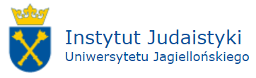

Social and Political Dynamics in Israel. Jewish State 70 Years after the Declaration of Independence
Krakow, May 7-9, 2018

Registration Form

Name: ....................................................................................................................................
Academic title: .......................................................................................................................
Academic affiliation: ..............................................................................................................
Mailing address: ....................................................................................................................

Abstract (200-250 words):
................................................................................................................................................
................................................................................................................................................
................................................................................................................................................
................................................................................................................................................
...............................................................................................................................................

Dietary restrictions:
.............................................................................................................................................
I would like to book a room at the Jagiellonian University’s guest house:
May 6/7 –
May 7/8 –
May 8/9 –
May 9/10 –

Please completethis form and send it by March 15, 2018to the e-mail address:israel2018@uj.edu.pl.
We will inform guests about accepting the submitted form by: March 30, 2018.
The final date for the conference fee payment: April 22, 2018.

You can find more information on our Facebook and website.

